TOUR TO MANUEL ANTONIO NATIONAL PARK
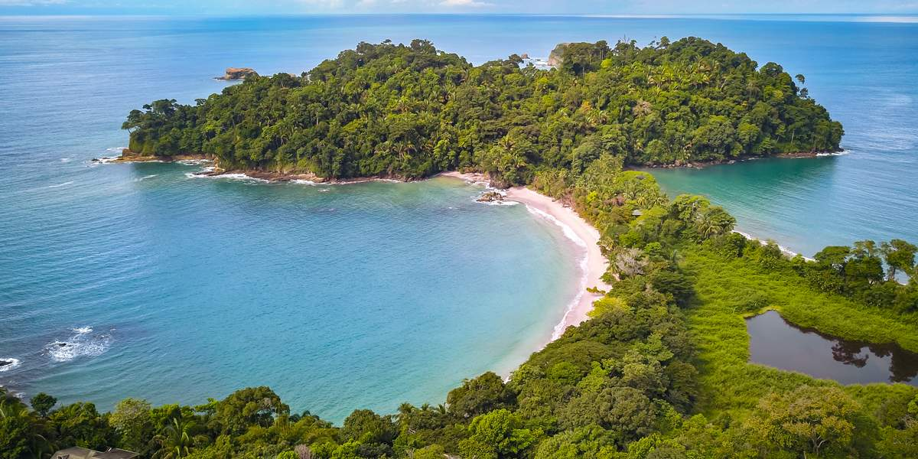
A tropical paradise awaits you

As part of the complementary activities of the congress, the following tour offer to Manuel Antonio National Park is presented, one of the most emblematic natural destinations in Costa Rica, recognized for its extraordinary biodiversity and its coastal landscapes of great scenic beauty.
This activity offers participants an additional opportunity to strengthen networking in a unique natural environment, fostering the exchange of ideas and interaction among researchers, professionals, and students who are part of the biomechanics community within the framework of the congress.
Participation in this tour is flexible: those who wish may remain at any point along the route and it is not mandatory to return to San José with the group, which allows participants to extend their stay in the Manuel Antonio area on their own. Likewise, this activity is open to the participation of family members or companions of the congress attendees.
For more information about Manuel Antonio National Park, please consult the following links:

https://www.sinac.go.cr/es/ac/acopac/pnma/paginas/default.aspx
https://www.manuelantonioparkonlineservices.com/

What does the tour include?
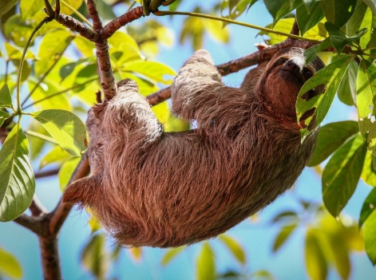
• Private transportation in an executive minibus, with pickup and return to Hotel Barceló.
• Two refreshments during the trip.
• Accompaniment of a certified professional tour guide inside the National Park.
• All entrance fees to Manuel Antonio National Park.
• Corresponding insurance, taxes, and administrative fees.
What is not included:
• Breakfast, lunch, or dinner.
• Souvenirs or keepsakes.
• Additional recreational activities not included in the itinerary.

Schedule and departure points:
5:00 am -Departure from Hotel Barceló San José. (Other strategic pickup points may possibly be assigned)
7:30 am Refreshment
9:00 am Typical breakfast at a local restaurant (not included in the fee)
10:00 am Entry to Manuel Antonio National Park
10:40-12:40 Guided tour
12:30-3:45 Free time on the park’s beaches with flexibility to explore different trails or points of interest on their own if desired.
3:45 pm Departure from the National Park
4:30 pm Restaurant for lunch or coffee (not included in the fee)
5:30 pm Departure towards Hotel Barceló San José
7:30 pm Refreshment
9:00 pm Return to Hotel Barceló San José
- Fees and payment methods:
Price per person:
  - Foreigners: 135 USD
  - Costa Ricans: 117 USD

- Payment method:
  - Foreigners: https://buy.onvopay.com/live_LSI_RnNbuBm19et3oBPki0ED8KE
  - Costa Ricans: https://buy.onvopay.com/live_2AVLirLmkl9JHOer5Ps3mLMEm7o

Información requerida:
Please complete the following information, which is essential to make the reservation of the entrance tickets to the National Park. We kindly ask you to return this document by replying to the same email.
Due to the high demand for visits to Manuel Antonio National Park, especially during high season, entrance tickets must be purchased in advance. For this reason, we request that the corresponding payment be completed and personal data be sent to events@rpbiomechanics.com no later than March 20, 2026.
Required information for each participant:
• Full name:
• Costa Rican identification number or passport:
• Country of residence:
